**Present:**

Phillip Atkinson, John Bruce, Brendan Burns, Lesley-Anne Cronin, Christine Dewar, Tim Hailey, George McLauchlan, Carole-Anne Patterson, Andy Smith, Bruce Stuart, Yvonne Crombie. Anne Smith

**Attending:**

Cllr. Backhouse, Cllr. Langlands, Cllr. Leslie, David Torrance MSP, Bill Kirkhope (Burgh Buzz), Ian Ralph CBTRA (Central Burntisland Tenants and Resident Association)

7 members of public.

1. **Chairman’s Opening Remarks and Apologies for Absence:**
   1. In the absence of Alex MacDonald, Vice Chair Bruce Stuart chaired the meeting.
   2. The Chairman welcomed members and public and reminded members that only items of urgent business would be taken under **11.0- A.O.B.**
   3. Apologies of absence from Alex MacDonald, Derek Turnbull.
2. **Minutes of previous meeting (7th March 2019):**
   1. The minutes were proposed by Tim Hailey and seconded by Lesley-Anne Cronan
3. **Secretary’s Report:**
   1. The secretary advised members that the ‘Event Group’, would be holding their A.G.M. at the Sands Hotel on Sunday 19th May at 11.00am.
   2. Notification had been received that the local T.S.B. branch would be cutting back opening hours to a Tuesday and Friday.
4. **Treasurer:**
   1. Report *(appendix 1)*
   2. The Treasurer advised members that the books for 2018/19 were with the independent auditor. The new financial year began on 1st April.
5. **Police**:
   1. Report *(Appendix 2)*
   2. Tim Hailey noted that although the crime rate had dropped for the period, the detection rate had also fallen. Ian Ralph (CBTRA), questioned the validity of the crime figures when comparing it with his own experience. Carole-Anne Patterson agreed with Ian, citing her own experience with regard to reporting cases of shoplifting, figures which are not quoted. John Bruce reiterated his plea for more visible policing.
   3. Andy Smith advised members that he had been unable to meet up with the community officers this month due to the short period in which they were available. Andy will try to arrange a meeting in the coming weeks. Andy said that policing methods had changed, local officers are told how to police, this is a national decision and not one that is made locally.
   4. Lesley-Anne Cronan told members that in her recent dealings with the police, she had found them responsive and helpful and it had generally been a positive experience.
6. **Environment:**
   1. John Bruce reported that he had been in contact with Fife Council regarding the bollards leading into the East end of the Links, these have since been repainted. A report on the poor state of the benches at the entrance to the Links has been submitted and awaits a reply.
   2. A ‘Beach Clean’ will be held on Saturday 4th May. Anyone wishing to help are advised to gather at the Beach car park (at the rear of the Beacon), at 10am.
   3. John expressed concern with access and maintenance to the ‘Shipyard Steps’, since news of the possible sale of Rossend castle. The Secretary said that he would contact the present owners to allay fears that access may be denied.
   4. Kirkton Burn. Andy Smith raised concerns with regard to the private clean-up recently of the burn at the Toll park. Andy stated that it was agreed at the last meeting that it was too late in the season to carry out a clean and that it should be delayed until the autumn. Cllr. Backhouse said that what had taken place was a litter pick and that some individuals had gone into the water to retrieve rubbish. Yvonne Crombie advised Andy that the group had taken expert advise on the dangers to the environment and were satisfied with measures in place. Cllr. Langlands advised members that work was ongoing to identify funding to replace fencing and do remedial work. David Torrance (MSP), advised members that the water quality in the burn was tested annually by SEPA, who also carried out a biodiversity report.

*Action- Secretary to contact Hurd Rolland re Shipyard Steps.*

1. **Planning:**
   1. Tim Hailey advised members that only two items were included in this month’s planning applications. The only item that would have bearing was the granting of permission for seating outside ‘Novello’s’ café. Members raised no objection.
2. **Burgh Buzz:**
   1. Bill Kirkhope advised members that copy deadline for the Spring issue was only days away. Bill was keen for members to supply him with articles. Bill reminded members that the Buzz depended on articles from contributors.
   2. David Torrance (MSP), congratulated Bill on the quality of the publication; David stated that he often used it as an excellent example of community newspapers.
3. **Awaiting Update:**
   1. Burgh Chambers Project. George McLauchlan advised members that he had received the final Business Plan for the project, however, there were a couple of adjustments which were required and he hoped to be able to present the finished report by the next meeting.
   2. Christmas Lights. Carole-Anne advised members that a bingo evening was being arranged for Friday 24th May. This was being held in the Jubilee Tavern. Members were asked to give their full support and to collect tickets from Carole-Anne at the end of the meeting. Carole-Anne also expressed her thanks to Dave Henderson of the Jubilee Tavern for the work he does in assisting with these events. Carole-Anne also thanked members who donated and assisted at the Tombola held on Saturday 30th March, this raised £183.61. A donation of £50 was received from Star Tavern.
   3. Paths Group. Anne Smith reported that work on the plan for improvements at Gale Slap/Binn Pond was ongoing. Gorse-cutting and general maintenance had been carried out at Glassliehead by a local walking group. There was news on Facebook about improving public access between Stenhouse Reservoir and Dunearn and also upgrading the path around the reservoir.
   4. Public Access Dock Area. The Vice Chair reported that the planned meeting with Forth Ports had been postponed and a new date was yet to be arranged.
   5. Community Action Plan Update. Yvonne Crombie asked what progress had been achieved with updating the report. Bruce Stuart advised Yvonne that the Chairman was working on this. Yvonne felt that this was an extremely important matter and should be looked at urgently. Yvonne offered her assistance to the Chairman with this task. It was agreed that a meeting with all of the groups involved with the CAP should be arranged. The Secretary will contact the Chairman to arrange this. Further progress will be discussed at the next meeting.
   6. Rail Station Access. George McLauchlan reported back on the meeting held by Leslie Laird MP, on 21st March. The hope that Burntisland would be included in the current round of expenditure on disabled access had been dashed. The local rail station did nor meet the criteria set out by Transport Scotland. It was important that the fight for funding should go on. A further meeting is planned for May.
      1. Cllr. Leslie said that it was unfortunate that the application had been unsuccessful, but that the ground work had been done for subsequent applications. David Torrance MSP, felt that the Community Council should be the driving force for the application; he cited several instances throughout Scotland where CCs were successful in pushing for rail access.
      2. A member of the public felt that many options for improving disabled access, such as the current underpass, had been ignored or difficulties thrown in the way.
      3. George McLauchlan drew members attention to the fact that Burntisland Community Development Trust were originally behind the drive to improve disabled access. He was unsure whether they were still involved, he would contact them to discuss.
      4. It was agreed that this was a too important matter to just leave. It will be added to the agenda and discussed at the next meeting in May.
   7. Lammerlaws Project. John Bruce reported on a on site visit he and George McLauchlan had with Craig Balfour of Fife Council. This walk-about was to discuss with Craig what was feasible on the site. Craig was very encouraging. It is hoped that Craig will report back before the next meeting. Anne Smith said that she was unaware of the meeting. The Secretary will ensure that Anne is added to the mailing list.
   8. Links Power Supply. Cllr. Langlands laid out the proposals being put forward by Fife Council for funding replacement of the power supply to the showground caravans. This will entail £100K coming from Burntisland Common Good Fund and £60K ATE Service (Fife Council). Andy Smith advised members that he had a Freedom of Information request in to Fife Council to ascertain ownership of the power supply. Bruce Stuart read out Alex MacDonald’s email on Fife Council’s legal obligations with regard to management of the Common Good. It was generally agreed that ownership of the original supply was essential to establish responsibility for replacement. Andy Smith advised members that he would contact the Secretary as soon as he hears back about his FOI request. Members agreed that it was essential that the supply was renewed but if the money for doing this was taken from the Common Good, this would set a precedent. On a show of hands, it was agreed that the Community Council would oppose Fife Council raiding the Common Good for the purpose of funding a replacement power supply. Further discussion will take place at May’s meeting. The Chairman will be asked to write to Fife Council stating the Community Councils position.

*Action- Alex to arrange new date for meeting with Forth Ports. Alex to continue with update of Community Action Plan and to liaise with Yvonne Crombie with regard to arranging meeting of interested parties. George to contact BCDT regarding their continued interest in station access. George to ensure that Anne Smith is on mailing list for Lammerlaws project. Alex to forward the Community Councils thoughts on funding of the Links power supply.*

10.0 **Date of Next Meeting 10th May 2019. 7.00pm**

***George D. McLauchlan 14th April 2019***

***Appendix 1***

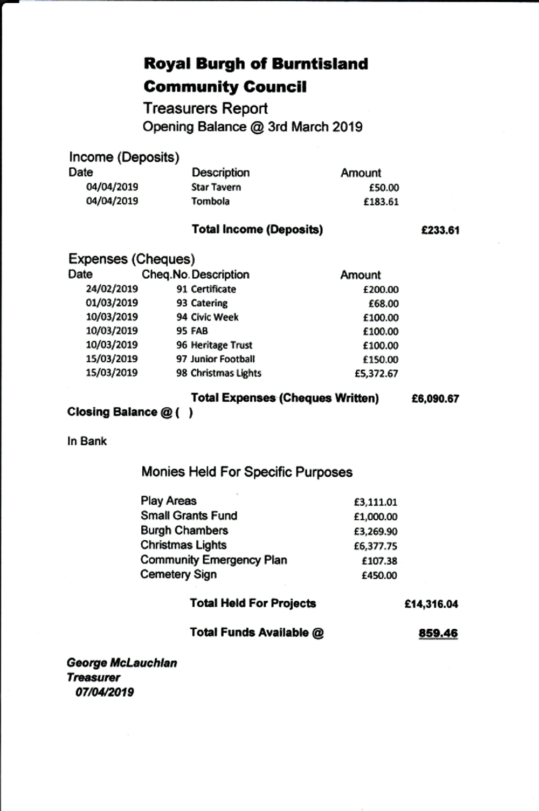

***Appendix 2***

